Unit 7 – Relational Database Build
Following the normalisation task, I used SQLite in Google Colab to create a relational database consisting of five linked tables: Student, Teacher, ExamBoard, Course and Enrolment. Primary, foreign and composite keys were used to maintain the relationships between the data.
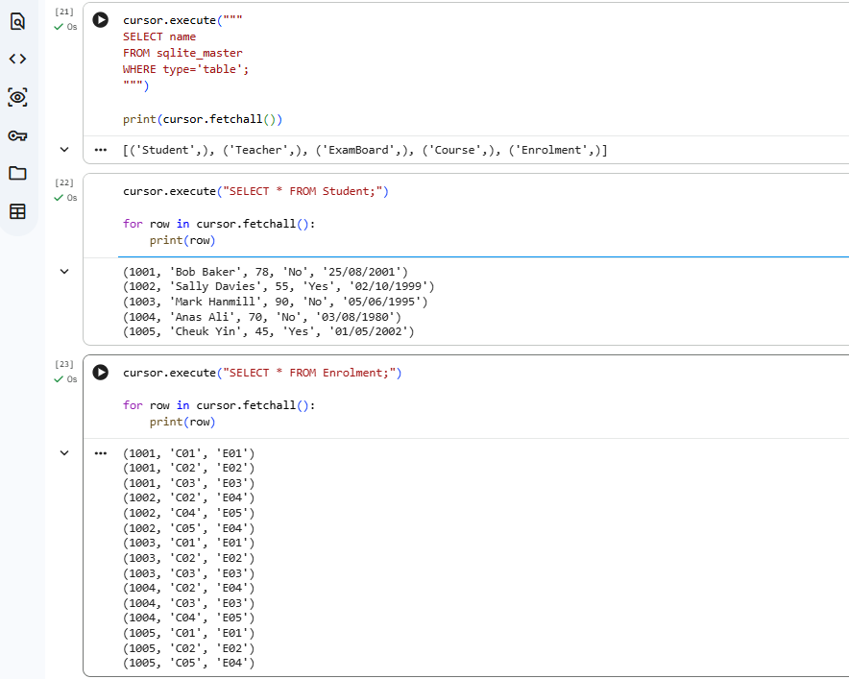

Figure 1. Creation and population of the relational database tables.

A SQL JOIN query successfully retrieved student, course, examination board and teacher information from the linked tables, demonstrating that the relationships were working correctly.
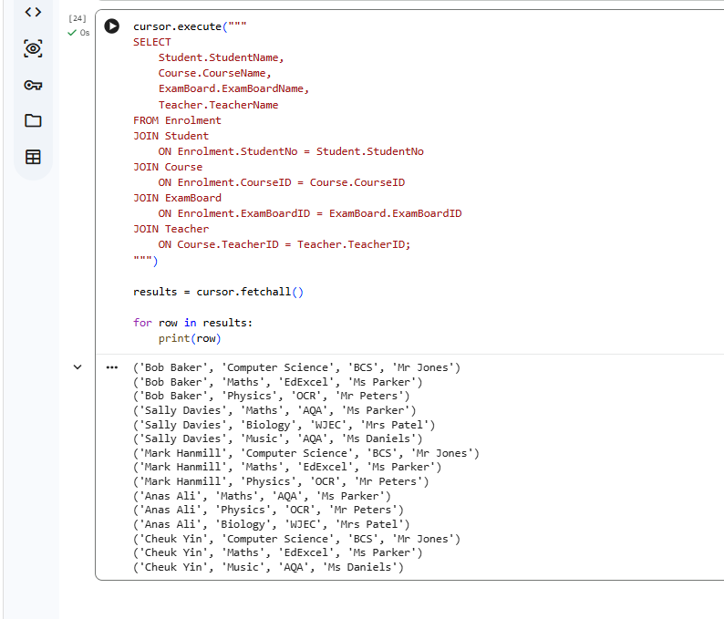
Figure 2. SQL JOIN query demonstrating successful relationships between the normalised tables.

Referential integrity was tested by attempting to add an enrolment for a non-existent student (9999). The database rejected the record with a FOREIGN KEY constraint failed error.
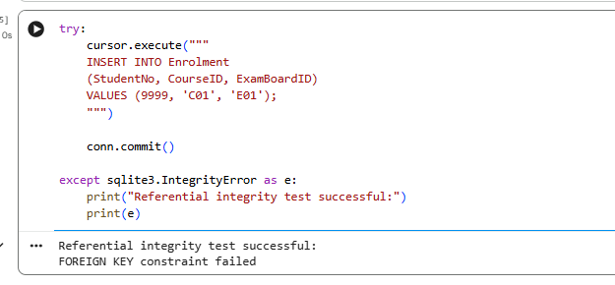

Figure 3. Successful referential integrity test.

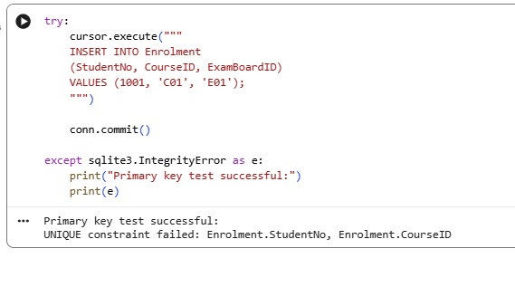
The composite primary key was also tested by attempting to duplicate an existing student-course combination. The UNIQUE constraint failed error confirmed that duplicate enrolments were prevented.

Figure 4. Successful composite primary key constraint test.

Reflection: This activity strengthened my understanding of how normalised tables are implemented within a relational database and how primary and foreign key constraints maintain data integrity and consistency.

